**Effects of 2019’s Social Protests on Emergency Health Services Utilization and Patients’ Severity in Santiago, Chile**

# Abstract

On October 18th, 2019, protestors gathered across Chile to call for social equality. The government responded by declaring a state of emergency and deploying the Chilean army and police, who utilized anti-riot shotguns and tear gas for crowd control. Despite the notorious impact of social protests on peoples’ lives, there is little scientific evidence of their broader health effects. This study aims to quantify the effects of the October 2019 Chilean protests on emergency health system services utilization and inpatient admission rates using ED public data.

**The next should be edited with the new methods and results**

Public data was pulled from the Chilean Ministry of Health and refined to isolate cases from age 15-64 within 3 kilometers of the protest focal point. A negative binomial model was fitted from 2015–2018 to forecast what would have happened in the absence of October’s social protests regarding trauma and respiratory cases. Predictions were compared to actual cases using t-tests and Mann-Whitney tests. Although increases in all trauma and respiratory cases were hypothesized, preliminary results varied. After October 18, trauma consultations within 1km were 19.7% lower than predicted while hospitalizations were 30.5% higher. Respiratory consultations and hospitalizations were not significantly different. Within 3km, trauma hospitalizations were 32.3% higher than predicted, respiratory consultations were 21.5% lower, and respiratory hospitalizations were 55.9% higher. Trauma consultations were not significantly different. The results demonstrate that shifts in patient utilization of emergency services occurred in response to widespread social protests, with consultations generally lower than predicted and hospitalizations higher than predicted. This study suggests there was a reduction in emergency services utilization and an increase in the severity of cases that actually presented to health services following the onset of the October 2019 Chilean protests.

# Introduction

Along its history the world has continually bared to social movements and civil unrest on the local, national, and global levels [1, 2]. Social movements are organized efforts by a group (or groups) of people working toward a common goal [3-5]. [6]. In Chile, protests of October 2019 were rooted in historical injustices and social inequality. The protestors were calling for structural changes related to wealth distribution, rising costs of living, stagnant wages, access and quality of basic public services (health, education, transport, justice system), and retirement pensions, among others [7, 8]. Without an organized leadership, this social movement featured high attendance rates and a strong national support. However, civil unrest collaterally occurred which leads the government to declare a state of emergency characterized by restricted mobility together with armed soldiers and policemen to control street disturbs [9, 10].

Whereas it is well known that social movements have an indirect impact on health, their short-term effect on health services utilization is less understood. Much of the current research linking social movements and health have focused on indirect effects of protest, demonstration, and civil unrest. For instance, civil unrest and violence expose people to stress that would contribute to mental health problems [11, 12]. Similarly, the shutdown of city streets, disruption of public transportation and damage to infrastructure could also affect health services [13 – 15]. Although there is lack current evidence, transportation issues and social insecurity during periods of civil unrest may also restrict patients’ access to health services [15]. Emergency departments (ED) consultations are influenced by access barriers [16 - 18] and serve as a measure of health service utilization. Nevertheless, how social movements and civil unrest affect emergency departments consultations is unknown.

On the other hand, crowd control techniques could also have adverse effects on health [19]. Rubber bullets have been cited to cause eye injuries, lacerations, contusions, and hematomas [20 – 23]. Burns and physical blows from batons, bottles, bricks, boots, and other objects also account for physical injury during protests [19, 22]. Of similar consequence, the use of tear gases –a subset of riot control agents that cause tears, eye pain, and difficulty keeping the eyes open– has been associated to short and long-term effects on the respiratory system [15, 19, 24 – 26] . However, most of these health adverse effects of crowd control techniques are based on case series. Whether crowd control techniques during civil unrest cause an increase in the severity of specific diseases at the population level has not been studied. Inpatient admission rate of ED consultations could serve as a proxy of disease severity to study this issue at the population level.

Social movement and civil unrest that took place in Chile in 2019 and the political decisions made to crowd control represent a natural experiment to study the effect of social protest on health. It is critical to understand how population-level events, like this, affect local and regional health systems utilization and how crowd-control techniques can affect the population health. Thus, this study aims to quantify the effects of the October 2019 Chilean protests on emergency health system services utilization and inpatient admission rates using ED public data.

# Methods

***Design and Data***

This study utilized a quasi-experimental study design with a controlled, interrupted time series analysis of aggregated weekly hospital emergency department admissions. The data was obtained through the Chilean Department of Health Information and Statistics, which collects ED consultations and hospitalization data concerning diagnosis and basic demographic information. Daily total emergency admission data of three major public hospitals in Santiago was gathered from 2015 to 2019 for both consultations and hospitalizations. Posteriorly, we aggregated the data into a weekly basis, although a lesser granularity. Also, ED consultations and hospitalizations for specific causes were collected: trauma, respiratory, diarrhea, and circulatory causes. Cases were defined according their main cause of admission. .

Santiago of Chile was the most affected city by the social movement in 2019, and the h is a place named “”, “Plaza Italia” or “Plaza dignidad”. Thus, we included cases from tertiary public hospitals located within 3 kilometers of this place (Hospital de Urgencia Asistencia Pública, Hospital Del Salvador de Santiago, Complejo Hospitalario San José). Two of these hospitals were within 1 kilometer of the “Plaza”.

**Exposure**



The exposure period was defined from the onset of social protests on October 18 until December 31 of 2019. The pre-exposure period was defined from August 1 to October 17, providing about 2 months of daily data pre- and post-exposure. We also explored on variables that affects the exposure to social protest: i) Days with bigger social unrest were identified through media and government reports (supplemental material) and compared with the other days. ii) biggerprotest exposure of patients.

***Outcome***

To account for health services utilization, we count total ED consultations and consultations for specific causes (trauma, respiratory, circulatory and diarrhea). To measure the cases severity, we count hospital admission from the ED to the same causes, except for diarrhea because this information was not available in the dataset. Hospital admission was based on physician criteria for each hospital.

XXXXXXXXXXX The next should be edited

***Analytic Approach***

We used historical controls to contrast observed ED consultation and hospitalizations in the exposure period, that is, we used the same outcomes in the same hospitals, for the same time of the year, but in a different period (2015-2018).

A preliminary visual analysis was performed to observe general trends in the data and understand any seasonality components we would have to consider in our time series modeling. It was determined that there was both annual and weekly seasonality in the data.

A negative binomial regression model was fitted to model consultation and hospitalization counts from August 1, 2019 to December 31, 2019 to predict daily case numbers for each outcome of interest.

The outcome was calculated as a function of multiple variables that included “Date,” “Year,” “Month,” “Day of Year,” “Day of Month,” “Day of Week,” “Case Number from Previous Day,” “Total Consultations or Hospitalizations – Outcome of Interest (OI) Consultations or Hospitalizations,” and “OI Consultations or Hospitalizations (opposite of OI).”

An offset was used to normalize values based on the total daily case numbers, where:

$${Offset}_{n}={\left(Total Consultations+Total Hospitalizations\right)}_{n}, n=Day of Year$$

To determine whether models for each outcome of interest met all assumptions, Breusch-Godfrey tests for serial correlation were performed.

The model was run using data from within 1km of Plaza Baquedano and repeated using data from within 3km to forecast new daily case numbers.

Predicted and actual daily case numbers for the 4 outcomes of interest within each geographic boundary were separated into the pre-exposure period and post-exposure period. For each of group of data, a Shapiro-Wilk test for normality was performed. Based on the results from these tests, a mean comparison analysis was performed using either an unpaired two-samples t-test or a Mann-Whitney U Test (Wilcoxon Rank Sum Test) to compare the actual vs. predicted mean daily case numbers for each outcome of interest. The calculated difference in means was defined by:

$$\overline{x}=\frac{\sum_{i=1}^{n}{A_{i}-P_{i}}}{n}$$

Where A = Actual Cases, P = Predicted Cases, and n = Number of Days in the Selected Exposure Period.

Seven-day moving average plots were created to visualize the actual and predicted case numbers (Figure 1, Figure 2, Figure 3, Figure 4).

Using Microsoft Excel for Microsoft 365 MSO (16.0.13029.20232) 64-bit, daily cumulative difference values from August 1 to December 31 were then calculated as defined by:

$$\sum_{i=1}^{n}{{((A-P)}_{i-1}+(A_{i}-P_{i})})$$

Where A = Actual Cases, P = Predicted Cases, and n = Number of Days in the Experimental Period.

Cumulative difference plots were then created using these values to visualize shifts in actual vs. predicted case numbers over time (Figure 1, Figure 2, Figure 3, Figure 4).

***Analytic Approach***

*Bayesian Structural Time-Series Analysis*

To evaluate the impact of social protest by comparing temporal trends to their counterfactuals, we used several Bayesian structural time series (*BSTS*) models {Scott, 2014 #7} implemented using the *CausalImpact* R package {Brodersen, 2015 #6}. This approach aims to estimate the impact of social protest on consultations and hospitalizations, by comparing the average value of consultations and hospitalizations after the event, with its estimated average value in a hypothetical scenario in which social protests did not occur, known as the counterfactual {Pinilla, 2018 #4}. The estimated effect is conceived as the difference between the constructed counterfactual and the observed number of consultations and hospitalizations after the social protest of October 18, 2019.

One of the advantages of this method is that it allows to flexibly infer the counterfactuals, its temporal evolution and incremental attributable impact. This estimation is achieved by incorporating features such as level, trends, seasonality and regression that captures the dynamics of the time series {Harvey, 2007 #1}. The first two components describe how the hospitalizations and consultations are related to underlying states, how the latent state changes over time. It is referred to as the unobserved trend inherent in time-series data. It is associated with a probability distribution of the noise and random disturbances, which let us incorporate empirical priors on the parameter and transitory or cyclic components able to approximate volatility in the series. The third components are the seasonal patterns that capture the associations between multiple fixed periodic events over the consultations and hospitalizations. We specified a monthly and annual seasonal patterns, based on theoretical backgrounds and the nature of admissions by its different causes. The fourth component relates to other contemporaneous time-series that can be used as covariates via linear regression. We selected the circulatory hospitalizationsand consultations. Because of the length of the time-series, we used a dynamic framework in which included the coefficients of time-varying regression.

Model selection considered alternative specifications to the models to the structure of the time-series of the hospitalizations and consultations of interest: Gaussian or studentized distributed noise, different trend drifts such as a random-walk, a semi-local linear trend or a local linear trend, or the inclusion of cyclicity of an autoregressive term of order 1. The evaluation of each model was conducted by comparing these preliminary models. We selected the models with lower cumulative absolute errors in the post-intervention period. This comparison allowed us to choose the specified structure with the most conservative estimates that resemble most to the post-intervention outcomes, to strengthen causal inference.

However, these estimates are embedded in uncertainty. To account for the degree of belief of the differences found between actual response to the posterior distribution {Scott, 2014 #7}, we constructed credible limits by estimating posterior probabilities through a 95% Bayesian credible interval. These intervals were generated from the distribution of 30,000 Markov chain Monte Carlo (MCMC) iterations/draws following a 10% burn-in period.

o estimate the causal effect of the bariatric surgery, we use the estimated states and parameters to forecast trajectories of the treated unit 𝑦̂ 0 0t for the post-intervention time points t = T0 +1, … , T. This procedure is repeated many times. Each draw of parameters from the posterior results in slightly different forecasts that are then averaged. Madigan and Raftery (1994) proved that averaging over an ensemble of models is at least as good as the best single model (see Fragoso, Bertoli, & Louzada, 2018, for a review on Bayesian model averaging). We compare the. This allows us to report the tail-area probability, that is, the probability under the calculated posterior that the response is at least as extreme (away from the expected value) as the observed one. Subtracting this predicted time series from the observed response during the post-intervention period yields a semiparametric Bayesian posterior distribution for the causal effect. We report the pointwise causal impact in this paper.

A typical method to produce forecasts in Bayesian data analysis is to use posterior simulations to generate draws from the posterior predictive distribution � � � , where � denotes the time series to be forecasted

All analyses and graphics were completed using R v 4.0.2.

***Outcome Validity Testing***

The validity of results was tested analytically through mean comparison analyses for pre-exposure data and visually by observing the difference between actual and predicted cases in seven-day moving average plots during the pre-exposure time frame.

# Results

***Within 1 Kilometer***

*Trauma Cases*

Significant differences were observed in post-exposure trauma consultations and hospitalizations within 1km of Plaza Baquedano. From October 18, 2019 to December 31, 2019, mean daily trauma consultations were 19.7% lower than predicted (p<0.001) while hospitalizations were 30.5% higher than predicted (p<0.001). These results are summarized in Table 2 and visualized in Figure 1.

*Respiratory Cases*

No significant differences were observed in post-exposure respiratory consultations or hospitalizations within 1km of Plaza Baquedano. Mean daily respiratory consultations were 9.2% higher than predicted (p=0.10) while hospitalizations were 25.1% higher than predicted (p=0.59). These results are summarized in Table 2 and visualized in Figure 2.

|  |  |  |  |  |  |
| --- | --- | --- | --- | --- | --- |
| Outcome of Interest | Mean Difference | Confidence Interval | P-Value | Mean Difference (%) | Confidence Interval (%) |
| Trauma Consultations | -15.47 | (-20.76, -10.19) | 4.71E-10 (MW) | -19.74 | (-26.49, -13.00) |
| Trauma Hospitalizations | 2.09 | (1.19, 2.98) | 2.32E-04 (MW) | 30.45 | (17.33, 43.56) |
| Respiratory Consultations | 0.71 | (-0.14, 1.55) | 0.10 (T) | 9.19 | (-1.77, 20.15) |
| Respiratory Hospitalizations | 0.36 | (-0.02, 0.73) | 0.59 (MW) | 25.10 | (-1.54, 51.73) |

Table 2: Mean comparison analysis results for post-exposure cases within 1km of Plaza Baquedano.

***Within 3 Kilometers***

*Trauma Cases*

Significant differences were observed in post-exposure trauma hospitalizations within 3km of Plaza Baquedano, but not in trauma consultations. Mean daily trauma consultations were 0.5% lower than predicted (p=0.35) while hospitalizations were 32.3% higher than predicted (p<0.001). These results are summarized in Table 3 and visualized in Figure 3.

*Respiratory Cases*

Significant differences were observed in post-exposure respiratory consultations and hospitalizations within 3km of Plaza Baquedano. Mean daily respiratory consultations were 21.5% lower than predicted (p<0.001) while hospitalizations were 55.9% higher than predicted (p<0.001). These results are summarized in Table 3 and visualized in Figure 4.

|  |  |  |  |  |  |
| --- | --- | --- | --- | --- | --- |
| Outcome of Interest | Mean Difference | Confidence Interval | P-Value | Mean Difference (%) | Confidence Interval (%) |
| Trauma Consultations | -0.63 | (-7.02, 5.77) | 0.35 (MW) | -0.54 | (-6.09, 5.01) |
| Trauma Hospitalizations | 2.79 | 1.77, 3.81) | 4.82E-07 (T) | 32.33 | (20.53, 44.13) |
| Respiratory Consultations | -3.56 | -4.74, -2.37) | 3.69E-08 (T) | -21.49 | (-28.67, -14.32) |
| Respiratory Hospitalizations | 1.04 | 0.60, 1.47) | 2.83E-05 (MW) | 55.92 | (32.57, 79.28) |

Table 3: Mean comparison analysis results for post-exposure cases within 3km of Plaza Baquedano.

***Validity Testing***

In the pre-exposure period, actual daily case numbers were found to be significantly different from predicted daily case numbers for several outcomes of interest (Table 4). Mean daily respiratory consultations in 2019 within 1km were 34.8% higher than predicted (p<0.001), respiratory hospitalizations within 1km were 7.3% lower than predicted (p<0.05), and trauma consultations within 3km were 9.5% higher than predicted (p<0.01).

Of note, these were the only 3 outcomes that demonstrated non-significant differences during the post-exposure period. However, two things come to attention here. First, the 7-day moving average plots demonstrate similar visual shifts in actual cases from the pre-exposure period to the post-exposure period. Respiratory consultations within 1km decrease, respiratory hospitalizations within 1km increase, and trauma consultations within 3km decrease (Figure 2, Figure 3). Second, the cumulative difference plots for these 3 outcomes demonstrate drastic changes in their slope beginning in the post-exposure period that mimic the changes in slope we observe for the same outcomes of interest in the other geographic boundary subgroup (Figure 2, Figure 3).

|  |  |  |  |  |  |
| --- | --- | --- | --- | --- | --- |
| Outcome of Interest | Mean Difference | Confidence Interval | P-Value | Mean Difference (%) | Confidence Interval (%) |
| Respiratory Consultations (1km) | 3.76 | (2.37, 5.16) | 4.75E-06 (MW) | 34.75 | (21.88, 47.62) |
| Respiratory Hospitalizations (1km) | -0.13 | (-0.48, 0.22) | 0.048 (MW) | -7.25 | (-26.71, 12.21) |
| Trauma Consultations (3km) | 10.73 | (3.54, 17.91) | 3.72E-03 (T) | 9.45 | (3.12, 15.78) |

Table 4: Significant results from mean comparison analyses of pre-exposure cases.

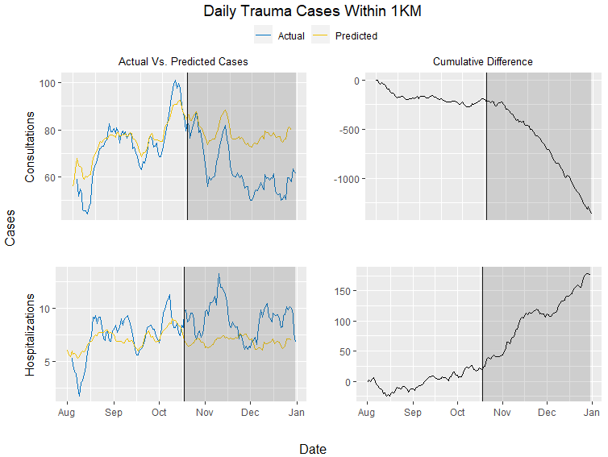

Figure 1: Seven-day moving average actual vs. predicted case plots and cumulative difference plots for daily trauma cases within 1km.

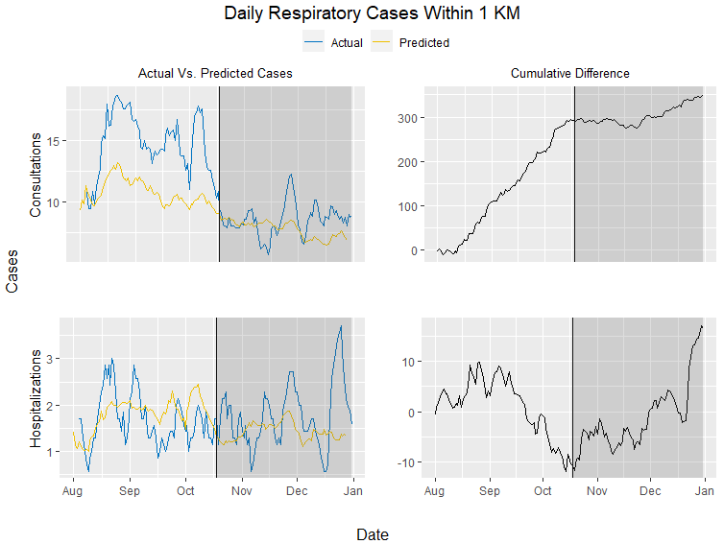

Figure 2: Seven-day moving average actual vs. predicted case plots and cumulative difference plots for daily respiratory cases within 1km.

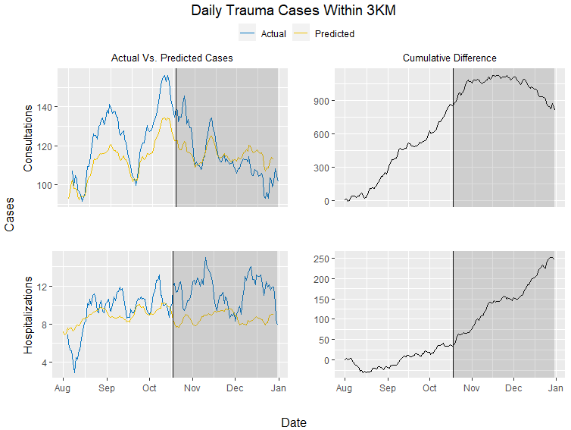

Figure 3: Seven-day moving average actual vs. predicted case plots and cumulative difference plots for daily trauma cases within 3km.

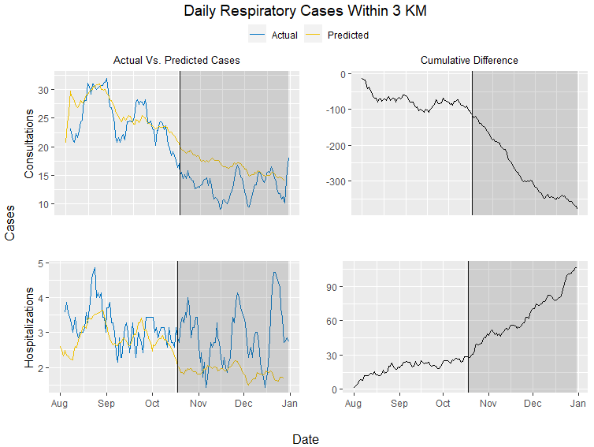

Figure 4: Seven-day moving average actual vs. predicted case plots and cumulative difference plots for daily respiratory cases within 3km.

# Discussion

*Findings*

This study demonstrates that shifts in patient utilization of emergency services occurred in response to widespread social protests. Generally, consultations were lower than predicted following the onset of the October social protests while hospitalizations were higher than predicted. In the three outcomes of interest that did not demonstrate significant differences in mean daily actual vs. predicted cases, relative shifts in daily case numbers were visualized when comparing the pre-exposure period to the post-exposure period. These shifts were most noticeable in the cumulative difference plots.

*Interpretations*

The findings in this study suggest that following the onset of the Chilean social protests on October 18th, 2019, there was a significant reduction in patient utilization of emergency services in Santiago. The findings also suggest that there was a relative increase in the severity of cases that actually presented to emergency services.

There are a few possible reasons for the reduction in emergency services utilization. During this protest period, individuals with non-severe or life-threatening emergencies who would normally visit emergency services may reasonably avoided these hospitals. As public transportation was significantly disrupted during the protests, prospective patients may not have even been able to make it to these hospitals to receive care.

The increase in hospitalizations, and therefore the relative increase in the severity of cases presenting to emergency services, is a little more complicated to interpret. The most reasonable explanation may be that increases in violence and the use of tear gases led to increased hospitalizations during the social protests. And while most minor and mild injuries were treated in site by health professional volunteering, there were still severe injuries that resulted from the civil unrest that required hospitalization within near hospitals. However, other explanations cannot be rejected at this point. For example, these shifts may also be due to a similar reason as the reduction in emergency services utilization. Patients may be avoiding care they need to resolve minor health issues, but in turn the health issues become worse until the patient must be hospitalized with what is now a severe medical case.

*Implications*

This paper used public access data to better understand the shifts in patient utilization of health systems services during the October 2019 Chilean protests. Gaps of knowledge in the health effects of social protests were identified and a method was developed to quantify shifts in health services utilization within a geographic boundary.

The results of this study should be seen as a first step in better understanding the broader health effects of largescale social protests like the Chilean protests but may have several implications moving forward. First, this evidence-based research could provide health services with crucial information during times of civil unrest and support decisions to reallocate resources to places where resources are most needed to provide sufficient care. Second, this research could be used as evidence to advocate for and advise policy change regarding law enforcement responses to civil unrest to reduce the broader negative health effects of social protests.

# Future Directions

This study is not yet complete—there is more work to be done. There are some interesting trends in the cumulative difference plots that need to be formally analyzed to support the current results or discover new trends in the data. There are also plans to match weekly differences in actual vs. predicted cases to peak protest dates to better understand the short-term effects of the protests on health services utilization. Further strategies will be assessed and performed to quantify whether shifts in trauma and respiratory cases were similar to those observed for other causes of emergency service utilization.

Lastly, a sensitivity analysis will be performed to better understand the results of the outcomes of interest that demonstrated significant pre-exposure differences in actual vs. predicted cases.

# Limitations

There were several limitations during the course of this study. The first and perhaps most important limitation was the difficulty in obtaining complete hospital data. Data was pulled from the Chilean Ministry of Health, which required many hospitals in the Santiago metropolitan region to submit daily admissions data, yet many hospitals did not do so. Many hospitals submitted incomplete records that had to be removed from analysis to avoid confounding the results, an issue most notable for private institutions and specialized “trauma hospitals”. Also, there was little data from private institutions, likely because these hospitals may not have had the same requirement to submit daily admissions data to the Ministry of Health. Because of this difficulty, we had to limit our analysis to 3 public institutions instead of the larger analysis we initially intended.

Another limitation of the study was the lack of specificity and pre-arrangement of admissions data into several categories. Data was already organized by case type without information regarding what specific cases fall into each category. Because of this, the analysis had to trust that each hospital categorized individual cases in a similar manner.

Another limitation relates to the lack of exogenous data, which would have reduced uncertainty estimates that would add sensibility to find major differences between the estimated counterfactuals and the hospitalizations and consultations. This limitation would be attributed to the difficulty to find covariates that were not affected by the intervention.

Taken from original introduction (could be used at the discussion)

Although the literature is far from a consensus, a social movement must have a common goal, joint action or effort against an antagonist, and some degree of organization and temporal continuity.9 These movements usually begin with an initiating event that sparks widespread discontent, such as the killing of George Floyd in Minneapolis, Minnesota in 2020 and the subway fare hike in Santiago, Chile in October 2019.10,11,2 Unorganized groups then join together into collective action to push for long-lasting change. Social movements typically end in success, failure, repression, co-optation, or establishment in the mainstream.10

During social movements, participants may intentionally cause public disturbance that violates the law - an act known as civil unrest.12 Participants can become hostile toward authority and may engage in violent or destructive actions that can have significant direct and indirect health effects on local populations.13,14,15

***Health effects of civil unrest***

Much of the current research linking social movements and health have focused on indirect effects of protest, demonstration, and civil unrest. For example, the shutdown of city streets, reductions in tourism, and disruption of public transportation can all affect the economy, which in turn can produce severe public health threats to local residents, such as food insecurity or a deterioration of hygiene condition.13,14,15 Although there is little current evidence, the onset of violence or the disruption of public transportation during periods of civil unrest may also cause restricted access to health services.

Evidence of the direct health effects of civil unrests are even more noticeable in media coverage. Crowd control methods during protests such rubber bullets have been cited to cause eye injuries, lacerations, contusions, and hematomas.16,17,18,27 Burns and physical blows from batons, bottles, bricks, boots, and other objects also account for physical injury during protests.17 Of similar consequence, the use of tear gases –a subset of riot control agents that cause tears, eye pain, and difficulty keeping the eyes open– are suggested to have the capacity to cause both short- and long-term negative health consequences on those affected.19,20,21 Short-term effects of tear gas exposure include coughing, wheezing, shortness of breath, laryngospasm, and acute respiratory arrest, with symptoms lasting upward of two weeks.20,21 Chronic bronchitis, reactive airway disease, and a variety of persistent respiratory symptoms (e.g. chest tightness, exercise dyspnea, daily phlegm) are all reported long-term effects of tear gas exposure. Other respiratory problems may arise from hazardous material exposure as a result of the burning and destruction of buildings and reductions in air quality in general, all of which may have significant public health implications.15

Despite what is known about the direct and indirect health effects of civil unrest, there is limited research regarding the effects of social protests on patient utilization of health system services, and most of what is known comes from non-scientific reports and media coverage.20,22

***The Chilean protests of 2019***

The Chilean protests of October 2019 were rooted in historical injustices and calls to equality. The current constitution was drafted under the Pinochet regime in 1980 without many of the human rights securities that protestors demand. Since this time, and especially after the return to democracy, there has been a rapid economic growth and an improvement of many social and health indicators (e.g. poverty, infant mortality, life expectancy). However, the country’s current economic model has reproduced many of the historical social inequities.2 The richest 1% of the Chilean population earns 33% of the nation’s wealth, while about 50% of Chilean workers make less than 400,000 pesos per month, roughly $550 USD.2,24,25

The protests were initially spurred by a metro fare increase of 30 pesos (about $0.04 USD), but the demonstrations quickly began to encompass the anger stemming from economic inequality and insufficient social services. Protestors called for structural changes related to social inequalities, rising costs of living, stagnant wages, and gender violence, as well as a new constitution.1 Demonstrations included the looting of supermarkets and the torching of 22 metro stations within the first week.2 The protests featured high attendance rates (more than 1.2 million people in Santiago alone) and strong national support, with 55% of Chileans supporting the continuation of the protests. Within days, the government declared a state of emergency and deploying the Chilean police, Carabineros, who utilized anti-riot shotguns and tear gas as a means of crowd control

# References

1. Vergara L. Why social movements matter for addressing inequalities and ensuring social justice. In: UNESCO/ISSC. World social science report, 2016: Challenging inequalities, pathways to a just world. Paris, France, 2016. Pages 250-53.
2. Berger S & Nehring H. Introduction: Towards a Global History of Social Movements. In: S. Berger, H. Nehring (eds.). The History of Social Movements in Global Perspective. Palgrave Macmillan UK, 2017. Pages 1-35.
3. . Scott J, Marshall G. A Dictionary of Sociology. 3rd ed. Oxford University Press; 2009. doi:10.1093/acref/9780199533008.001.0001
4. Opp K-D. Theories of Political Protest and Social Movements: A Multidisciplinary Introduction, Critique, and Synthesis. Routledge; 2009.
5. Diani M. The Concept of Social Movement. Sociol Rev. 1992;40(1):1-25. Doi:10.1111/j.1467-954X.1992.tb02943.x
6. https://www.nfpa.org/-/media/Files/News-and-Research/Resources/Fire-service/Responder-Forum/2015-NFPA-responders-forum-Civil-Unrest-Paper.ashx?la=en
7. Krygier R. Chile is preparing to rewrite its constitution. Why are people still protesting? Washington Post. https://www.washingtonpost.com/world/the_americas/chile-is-preparing-to-rewrite-its-constitution-why-are-people-still-protesting/2020/02/01/eb7ee6b2-43cc-11ea-99c7-1dfd4241a2fe_story.html. Accessed August 11, 2020.
8. Johanson M. How a 4-cent metro fare price hike sparked massive unrest in Chile. Vox. Published October 29, 2019. Accessed August 9, 2020. <https://www.vox.com/world/2019/10/29/20938402/santiago-chile-protests-2019-riots-metro-fare-pinera>
9. von Elm E, Madrid E, Urrutia G. Chile: civil unrest and Cochrane Colloquium cancelled. Lancet . 2019 Nov 9;394(10210):e35.
10. emol. [La cronología de los hechos que detonaron la crisis social y los días de estado de emergencia en el país]. Avaible on: https://www.emol.com/noticias/Nacional/2019/10/23/965179/Cronologia-Crisis-Social-Evasion-Protestas.html
11. Yimgang DP, Wang Y, Paik G, Hager ER, Black MM. ivil Unrest in the Context of Chronic Community Violence: Impact on Maternal Depressive Symptoms. Am J Public Health . 2017 Sep;107(9):1455-1462
12. Dangmann CR, Solberg Ø, Steffenak AKM, Høye S, Andersen PN. Health-related quality of life in young Syrian refugees recently resettled in Norway. Scand J Public Health . 2020 Jul 2;1403494820929833
13. Evans CA Jr. Public health impact of the 1992 Los Angeles civil unrest. Public Health Rep . May-Jun 1993;108(3):265-72.
14. Robertson E. Venezuelan unrest increases pressure on health services. Lancet . 2014 Mar 15;383(9921):942.
15. The Lancet Oncology. Hong Kong: long civil unrest with long-term consequences. Lancet Oncol . 2020 Jan;21(1):1.
16. . Rust G et al. Practical barriers to timely primary care access: impact on adult use of emergency department services. Arch Intern Med . 2008 Aug 11;168(15):1705-10
17. Jones AP, Bentham G, Horwell C. Health service accessibility and deaths from asthma. Int J Epidemiol . 1999 Feb;28(1):101-5.
18. Nicholl J, West J, Goodacre S, Turner J. The relationship between distance to hospital and patient mortality in emergencies: an observational study. Emerg Med J . 2007 Sep;24(9):665-8.
19. Ballantyne B. Medical management of the traumatic consequences of civil unrest incidents: causation, clinical approaches, needs and advanced planning criteria. Toxicol Rev . 2006;25(3):155-97.
20. Rodríguez Á, Peña S, Cavieres I, et al. Ocular trauma by kinetic impact projectiles during civil unrest in Chile [published online ahead of print, 2020 Aug 24]. *Eye (Lond)*. 2020;1-7. doi:10.1038/s41433-020-01146-w
21. Blain PG. Tear Gases and Irritant Incapacitants: 1-Chloroacetophenone, 2-Chlorobenzylidene Malononitrile and Dibenz[B,F]-1,4-Oxazepine. Toxicol Rev. 2003;22(2):103-110. doi:10.2165/00139709-200322020-00005
22. Arbak P, Başer İ, Kumbasar ÖO, Ülger F, Kılıçaslan Z, Evyapan F. Long Term Effects of Tear Gases on Respiratory System: Analysis of 93 Cases. The Scientific World Journal. doi:https://doi.org/10.1155/2014/963638
23. Uslu E, Ozkan G, Kucuk CU, et al. Respiratory effects of tear gas inhalation. Eur Respir J. 2014;44(Suppl 58). Accessed August 13, 2020. https://erj.ersjournals.com/content/44/Suppl_58/P4958

# OLD REFERENCE LIST

1. Krygier R. Chile is preparing to rewrite its constitution. Why are people still protesting? *Washington Post*. https://www.washingtonpost.com/world/the_americas/chile-is-preparing-to-rewrite-its-constitution-why-are-people-still-protesting/2020/02/01/eb7ee6b2-43cc-11ea-99c7-1dfd4241a2fe_story.html. Accessed August 11, 2020.

2. Johanson M. How a 4-cent metro fare price hike sparked massive unrest in Chile. Vox. Published October 29, 2019. Accessed August 9, 2020. https://www.vox.com/world/2019/10/29/20938402/santiago-chile-protests-2019-riots-metro-fare-pinera

3. World Report 2020: Rights Trends in Chile. Human Rights Watch. Published December 6, 2019. Accessed August 11, 2020. https://www.hrw.org/world-report/2020/country-chapters/chile

4. Departamento de Estadisticas e Información de Salud. Accessed August 13, 2020. https://deis.minsal.cl/

5. Hine DC, Morris AD. The Origins of the Civil Rights Movement: Black Communities Organizing for Change. *J South Hist*. 1985;51(4):652. doi:10.2307/2209556

6. Campante FR, Chor D. Why Was the Arab World Poised for Revolution? Schooling, Economic Opportunities, and the Arab Spring. *J Econ Perspect*. 2012;26(2):167-188. doi:10.1257/jep.26.2.167

7. Scott J, Marshall G. *A Dictionary of Sociology*. 3rd ed. Oxford University Press; 2009. doi:10.1093/acref/9780199533008.001.0001

8. Opp K-D. *Theories of Political Protest and Social Movements: A Multidisciplinary Introduction, Critique, and Synthesis*. Routledge; 2009.

9. Diani M. The Concept of Social Movement. *Sociol Rev*. 1992;40(1):1-25. doi:10.1111/j.1467-954X.1992.tb02943.x

10. Four Stages of Social Movements. Accessed August 9, 2020. https://www.ebscohost.com/uploads/imported/thisTopic-dbTopic-1248.pdf

11. George Floyd, From ‘I Want to Touch the World’ to ‘I Can’t Breathe’ - The New York Times. Accessed August 9, 2020. https://www.nytimes.com/article/george-floyd-who-is.html

12. 2015-NFPA-responders-forum-Civil-Unrest-Paper.pdf. Accessed August 9, 2020. https://www.nfpa.org/-/media/Files/News-and-Research/Resources/Fire-service/Responder-Forum/2015-NFPA-responders-forum-Civil-Unrest-Paper.ashx?la=en

13. Unrest is costing Chile’s economy, but protesters press on. Accessed August 9, 2020. <https://www.aljazeera.com/ajimpact/unrest-costing-chiles-economy-protesters-press-191210194124885.html>

14. Chile announces $5.5 billion economic recovery plan as protests bite - Reuters. Accessed August 9, 2020. <https://www.reuters.com/article/us-chile-economy-imacec/chile-announces-5-5-billion-economic-recovery-plan-as-protests-bite-idUSKBN1Y6173>

15. Evans CA. Public health impact of the 1992 Los Angeles civil unrest. *Public Health Rep*. 1993;108(3):265-272.

16. Balouris CA. Rubber and plastic bullet eye injuries in Palestine. *The Lancet*. 1990;335(8686):415. doi:10.1016/0140-6736(90)90252-Z

17. The injuries and management of riot casualties admitted to the belfast hospital wards, August to October, 1969 - Robb - 1971 - BJS (British Journal of Surgery) - Wiley Online Library. Accessed August 13, 2020. <https://bjssjournals.onlinelibrary.wiley.com/doi/pdf/10.1002/bjs.1800580604?casa_token=Xlr6xVzi_hUAAAAA%3AwLn8C9fRQtz3gFXx7a7jhbuUJ5UyLCBRSCyj0UG4Kq4aen5HtNA5H6lLcDu-rA7wFNpGYuHrFXd7ecC7>

18. Sheridan S, Whitlock, Roy, I.H. Plastic Baton Round Injuries. *British Journal of Oral Surgery*. 1983;21: 259-267.

19. Blain PG. Tear Gases and Irritant Incapacitants: 1-Chloroacetophenone, 2-Chlorobenzylidene Malononitrile and Dibenz[B,F]-1,4-Oxazepine. *Toxicol Rev*. 2003;22(2):103-110. doi:10.2165/00139709-200322020-00005

20. Arbak P, Başer İ, Kumbasar ÖO, Ülger F, Kılıçaslan Z, Evyapan F. Long Term Effects of Tear Gases on Respiratory System: Analysis of 93 Cases. The Scientific World Journal. doi:https://doi.org/10.1155/2014/963638

21. Uslu E, Ozkan G, Kucuk CU, et al. Respiratory effects of tear gas inhalation. *Eur Respir J*. 2014;44(Suppl 58). Accessed August 13, 2020. https://erj.ersjournals.com/content/44/Suppl_58/P4958

22. Hu H, Christiani D. Reactive airways dysfunction after exposure to teargas. *The Lancet*. 1992;339(8808):1535. doi:10.1016/0140-6736(92)91296-K

23. What lies behind the protests in Venezuela? *BBC News*. https://www.bbc.com/news/world-latin-america-26335287. Published March 27, 2014. Accessed August 11, 2020.

24. Palet A, Aguirre P de, PNUD Chile, eds. *Desiguales: Orígenes, Cambios y Desafíos de La Brecha Social En Chile*. PNUD : Uqbar Editores; 2017.

25. Los-Verdaderos-Salarios-ESI-2018-1.pdf. Accessed August 11, 2020. <http://www.fundacionsol.cl/wp-content/uploads/2019/08/Los-Verdaderos-Salarios-ESI-2018-1.pdf>

26. Informe de resultados oficial Encuesta Zona Cero. *Núcleo de Sociología Contingente.* 2020. <https://doi.org/10.31219/osf.io/76mdz>. Accessed September 8, 2020.

27. Rodríguez Á, Peña S, Cavieres I, et al. Ocular trauma by kinetic impact projectiles during civil unrest in Chile [published online ahead of print, 2020 Aug 24]. *Eye (Lond)*. 2020;1-7. doi:10.1038/s41433-020-01146-w